Math Supplies

- 2 pks. sharpened #2 pencils (Ticonderoga brand is
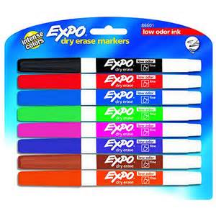
the most durable.)

- 18 or 12 pkg. low odor dry erase markers
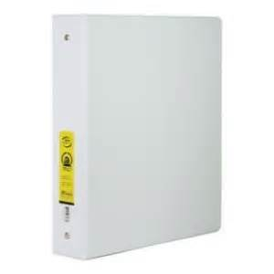

- One 1 1/2’” three ring binder
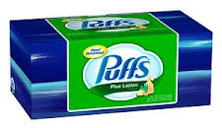

- 1 box of tissues

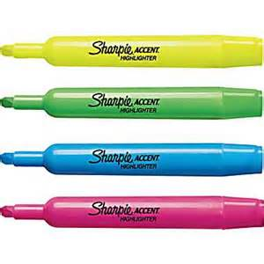
- Two thin highlighters

